TEMPLATE FOR ABSTRACT
Comparison of GeS₂ crystal growth kinetics in (GeS₂)_{x}(Sb₂S₃)_{1-x} (x=1;0,9;0,8) thin film glasses

V. Podzemná, J. Barták, J. Málek

Department of Physical Chemistry, University of Pardubice, Studentska 573, Pardubice 532 10, Czech Republic
Corresponding e-mail: veronika.podzemna@upce.cz

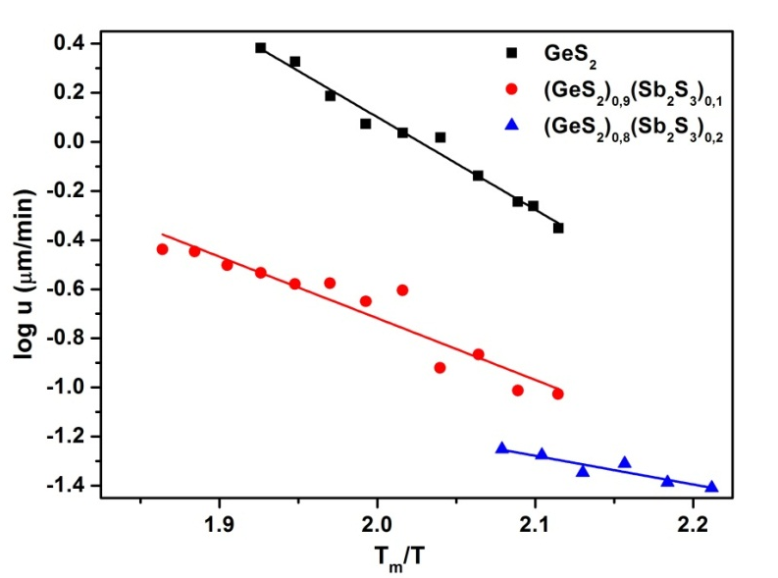
During the last three decades much attention has been devoted to the properties of chalcogenide glasses. Glasses based on germanium disulfide are widely studied due to their high infrared transparency which is also used for construction of passive optical elements used in the IR region [1]. In this contribution we will focus on optical study of germanium disulfide crystal growth rate in undercooled melt of (GeS₂)_{x}(Sb₂S₃)_{1-x} system where x=1; 0,9; 0,8.
The process of crystallization was investigated in thin film form for all compositions x=1; 0,9; 0,8. Thin films were prepared by the simplest way of material deposition on substrate, it means by vacuum thermal evaporation. The thickness of all prepared films was about 1µm. Small pieces of samples were separately temperated in furnace for specified time at selected temperatures.
The crystal growth was observed by optical microscope Olympus BX51. Based on optical monitoring crystal growth rate could be calculated. Reduced growth rate was set by using the viscosity data [2]. Temperature models of crystal growth rate were predicted for all compositions.

The authors thank to project CZ.1.07/2.3.00/20.0254 “ReAdMat - Research Team for Advanced Non-Crystalline Materials” cofinanced by the European Social Fund and the state budget of the Czech Republic.
References
[1] J. Málek, J. Thermal. Anal. 40 (1993) 159-170
[2] J. Shánělová et al., J. Non-Cryst. Solids 352 (2006) 3952-3955

- please send abstracts in English only
- for your abstracts, please follow the above mentioned instructions given in the abstract template (alignment, font type and size, reference format…)
- equations, figures, schemes or tables should be inserted into the text
- the extent of the abstract should not exceed one A4 page, recommended minimum is 2000 characters including spaces

