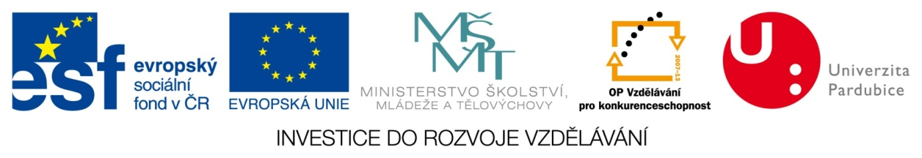
International Days of Materials Science - ReAdMat 2014
16. – 17. 9. 2014 Hotel Zlata Stika, Strossova 127, 530 02 Pardubice

REGISTRATION FORM

Please complete the following information.
Required fields are marked with *.
Completed registration form including abstract (see below), please send it till 6. 8. 2014 to the e-mail: IDMSconference@gmail.com. Attention-limited capacity!

Personal details
Last name *

First name *

Title (Prof/Dr/Ms/Mr)*

Gender * |  | Female / male
Institution / University / Company *

Address / P.O. Box *

Postal code *

City *

Country / region *

Phone (country code, area code, phone number) *

E-mail *
All correspondence will be sent to this address
so please make sure it is typed correctly.
Accompanying person's last name

First name
Presentation
Type of contribution*  Title of contribution* | Oral presentation/poster
Dietary restrictions, special diets etc.
Vegetarians |  | Yes / No
Others special information

